**Group 1: Body odour**

When children reach puberty, a sweat gland in their armpit and genital area develops. Skin bacteria feed on the sweat this gland produces, which is why teenagers – and adults! – sometimes smell ‘sweaty’. Bacteria feed on sweat in other parts of the body too, which can lead to body odour (BO).

If your child washes her body and changes her clothes regularly, especially after physical activity, it’ll help to reduce the build-up of bacteria and avoid BO. Changing underwear and other clothes worn next to the skin is especially important. These clothes collect stuff that bacteria love to eat, including dead skin cells, sweat and body fluids. That’s why they get smelly.

The onset of puberty is also a good time for your child to start using **antiperspirant deodorant**. You can encourage your child to do this by letting him choose his own.

[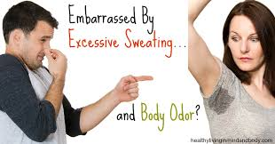](https://www.google.com.au/imgres?imgurl=http://healthylivinginbodyandmind.com/wp-content/uploads/2014/01/Sweating1.jpg&imgrefurl=http://healthylivinginbodyandmind.com/are-you-embarrassed-by-excessive-sweating-and-body-odor/&docid=cJvWhh1Sk0cpCM&tbnid=9OKZwaqvEs3UQM:&vet=1&w=800&h=419&bih=805&biw=1440&ved=0ahUKEwjpwoCcstTQAhWBEpQKHa0gAQ0QMwh-KEMwQw&iact=mrc&uact=8)[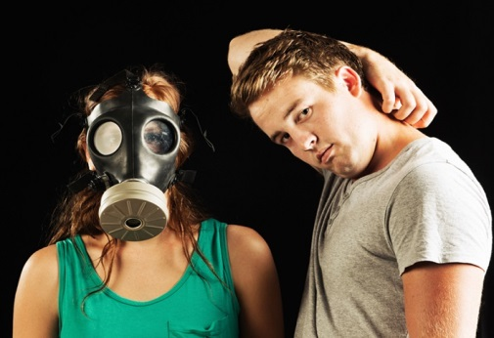](http://www.google.com.au/url?sa=i&rct=j&q=&esrc=s&source=images&cd=&cad=rja&uact=8&ved=0ahUKEwiB06mrstTQAhWBEpQKHa0gAQ0QjRwIBw&url=http://www.foodofy.com/foods-that-can-increase-your-body-odour.html&psig=AFQjCNEW5uh1u-3ko5uaTbnk7vrR7z-kXw&ust=1480729726719321)

_________________________________________________________

**Group 2: Smelly feet**

Smelly feet and shoes can also be a problem for your child, whether she’s sporty or not. She can avoid this by giving her feet extra attention in the shower, and making sure they’re completely dry before putting her shoes on. It’s a good idea to encourage her to alternate her shoes and to wear cotton socks instead of ones made of synthetic fibres.

[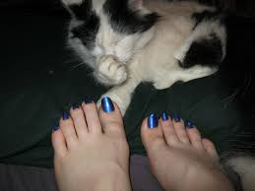](https://www.google.com.au/imgres?imgurl=http://img07.deviantart.net/d9dc/i/2012/206/a/1/smelly_feet_by_epicravemonster-d58masv.jpg&imgrefurl=http://bohemian-minx.deviantart.com/art/Smelly-Feet-316808239&docid=Y79Jq6OblgQeiM&tbnid=XpjE8GL1utBDTM:&vet=1&w=800&h=600&bih=805&biw=1440&ved=0ahUKEwjt-76Fs9TQAhXEUZQKHRtrAxsQMwiKAShTMFM&iact=mrc&uact=8)[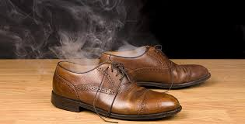](https://www.google.com.au/imgres?imgurl=http://www.prevention.com/sites/prevention.com/files/styles/article_main_image_2200px/public/articles/2015/06/getty-95403447-smelly-shoes-joe-belanger.jpg?itok=ul1sp4tS&imgrefurl=http://www.prevention.com/health/prevent-smelly-feet&docid=sSFnua6A2v6j5M&tbnid=urE0kPR_pWPePM:&vet=1&w=650&h=330&bih=805&biw=1440&ved=0ahUKEwjt-76Fs9TQAhXEUZQKHRtrAxsQMwhdKCYwJg&iact=mrc&uact=8)

_________________________________________________________

**Group 3: Dental hygiene**

Good dental and mouth hygiene is as important now as it was when your child was little, and you’ll need to keep making regular dental appointments for him. Brushing twice a day, flossing and going to the dentist regularly are vital if your child wants to avoid bad breath, gum problems and tooth decay.

You can read more about [dental care for pre-teens](http://raisingchildren.net.au/articles/dental_care_preteens.html) and [dental care for teenagers](http://raisingchildren.net.au/articles/dental_care_early_teens.html).

[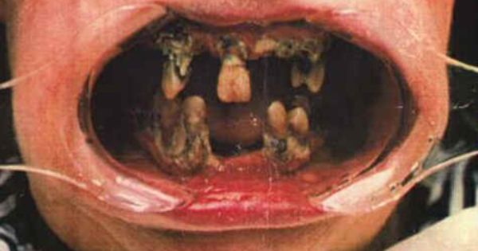](https://www.google.com.au/url?sa=i&rct=j&q=&esrc=s&source=images&cd=&cad=rja&uact=8&ved=0ahUKEwj95o6ZtNTQAhVCI5QKHdDCAKsQjRwIBw&url=https://www.pinterest.com/pin/195906652515128317/&bvm=bv.139782543,d.dGo&psig=AFQjCNEHkMoPCERcymDXM0DPJktuTMWiAA&ust=1480730242604368)[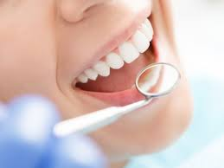](http://www.google.com.au/url?sa=i&rct=j&q=&esrc=s&source=images&cd=&cad=rja&uact=8&ved=0ahUKEwinlOCztNTQAhUKl5QKHYpHCuwQjRwIBw&url=http://themocracy.com/the-ultimate-dental-hygiene-guide-for-children/&bvm=bv.139782543,d.dGo&psig=AFQjCNH1UzrXwu_syeUw9oYBAImaAWRzfQ&ust=1480730301132098)

**Group 4: Personal hygiene for girls**

Although all teenagers have the same basic hygiene issues, girls will need help to manage their [periods](http://raisingchildren.net.au/articles/periods.html). For example, you might need to talk with your daughter about how often to change her pad or tampon, and how to dispose of it hygienically.

[](http://www.google.com.au/url?sa=i&rct=j&q=&esrc=s&source=images&cd=&cad=rja&uact=8&ved=0ahUKEwjexdeZtdTQAhWFI5QKHeFxAjoQjRwIBw&url=http://www.thehealthyhomeeconomist.com/nontoxic-alternatives-to-tampons-and-sanitary-napkins/&bvm=bv.139782543,d.dGo&psig=AFQjCNFRdLNTW0MnLDtshNqLm37JwE4k3g&ust=1480730507888943)

_________________________________________________________

**Group 5: Personal hygiene for boys**

Boys will need advice about shaving (how to do it and when to start), looking after their genitals, and about bodily fluids. For example, you might talk to your son about wet dreams and how to clean up hygienically afterwards.

[](http://www.google.com.au/url?sa=i&rct=j&q=&esrc=s&source=images&cd=&cad=rja&uact=8&ved=0ahUKEwijoJjltdTQAhVCkJQKHSD-CEQQjRwIBw&url=http://www.nighthawkbedwetting.com/bed-wetting-information/bedwetting-in-adolescents/&bvm=bv.139782543,d.dGo&psig=AFQjCNFp__-zgcB8x5BXfqduiTVaAXIqbg&ust=1480730672671801)  
__________________________________________________________________________________